AS Level Chemistry

A guide to help you prepare yourself for studying AS Level Chemistry

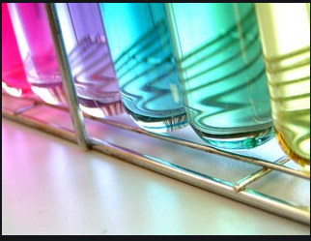

**Book Recommendations**

|  |  |
| --- | --- |
|  | **Periodic Tales: The Curious Lives of the Elements**  The phenomenal bestseller by Hugh Andersey-Williams, packed with fascinating stories and unexpected information about the building blocks of our universe. |
| **A Short History of Nearly Everything**  A whistle-stop tour through many aspects of history from the Big Bang to now. This is a really accessible read that will re-familiarise you with common concepts and introduce you to some of the more colourful characters from the history of science! |  |
|  | **The Science of Everyday Life: Why Teapots Dribble, Toast Burns and Light Bulbs Shine**  Have you ever wondered why ice floats and water is such a freaky liquid? Or why chillies and mustard are both hot but in different ways? Or why microwaves don't cook from the inside out? In this fascinating scientific tour of household objects, Marty Jopson has the answer to all of these, and many more, baffling questions about the chemistry and physics of the everyday stuff we use every day. |
| **Bad Science**  Ben Goldacre masterfully dismantles the dubious science behind some of the great drug trials, court cases, and missed opportunities of our time. He also shows us the fascinating story of how we know what we know, and gives us the tools to uncover bad science for ourselves. |  |

Movie Recommendations

Here are some films based on real life scientists and discoveries - great watching for a rainy day!

|  |  |
| --- | --- |
|  | **Erin Brockovich (2000)**  Erin Brockovich is a woman in a tight spot. Following a car accident in which Erin is not at fault, Erin pleads with her attorney Ed Masry to hire her at his law firm. Erin stumbles upon some medical records placed in real estate files. She convinces Ed to allow her to investigate, where she discovers a cover-up involving contaminated water in a local community that is causing devastating illnesses among its residents. |
| **Dante’s Peak (1997)**  Disaster follows when a long-dormant volcano suddenly reawakens. When strange things begin to happen around the peaceful town of Dante's Peak, noted vulcanologist Harry Dalton is sent to investigate. Harry's investigation leads him to believe that a volcanic catastrophe is imminent, although his disbelieving superior refuses to warn the townsfolk. |  |
|  | **Fantastic Four (2005)**  Mr. Fantastic, who can elongate his body; Invisible Woman, who not only can become invisible at will but can render other objects invisible; Human Torch, who can shoot fire from his finger tips and bend flame; and The Thing, a hideously misshapen monster with superhuman strength, together battle the evil Doctor Doom. |

**Other on screen recommendations:**

* **Rough science – the Open University – 34 episodes available**

Real scientists are ‘stranded’ on an island and are given scientific problems to solve using only what they can find on the island.

Great fun if you like to see how science is used in solving problems.

<https://www.youtube.com/playlist?list=PLMC_-FtZbKXJRIWszjknt63nR9ETWS8rY>

* **A thread of quicksilver – The Open University**

A brilliant history of the most mysterious of elements – mercury. This program shows you how a single substance led to empires and war, as well as showing you come of the cooler properties of mercury.

<https://www.youtube.com/watch?v=t46lvTxHHTA>

* **Faces of chemistry – Royal Society of Chemistry**

Have you ever wondered what events inspired famous chemists? Or how chemistry research leads to new products and technologies? Or what sort of careers studying chemistry can lead to?

Faces of Chemistry is a rich collection of videos and resources about chemistry in real life, through the careers of real people.

<https://edu.rsc.org/resources/collections/faces-of-chemistry>

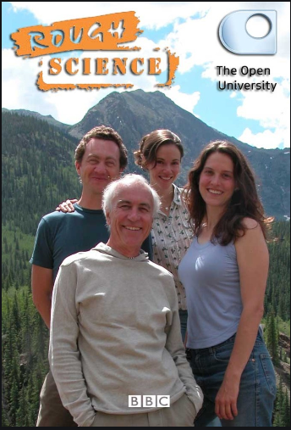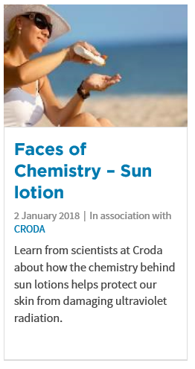

**TED Talks**

|  |  |  |
| --- | --- | --- |
| **The incredible chemistry powering your smartphone** | Ever wondered how your smartphone works? Take a journey down to the atomic level with scientist Cathy Mulzer, who reveals how almost every component of our high-powered devices exists thanks to chemists -- and not the Silicon Valley entrepreneurs that come to most people's minds. As she puts it: "Chemistry is the hero of electronic communications." |  |
| **A crash course in organic chemistry** | Jakob Magolan is here to change your perception of organic chemistry. In an accessible talk packed with striking graphics, he teaches us the basics while breaking the stereotype that organic chemistry is something to be afraid of. |  |
| **The chemistry of cookies** | You stick cookie dough into an oven, and magically, you get a plate of warm, gooey cookies. Except it's not magic; it's science. Stephanie Warren explains via basic chemistry principles how the dough spreads out, at what temperature we can kill salmonella, and why that intoxicating smell wafting from your oven indicates that the cookies are ready for eating. |  |
| **How pollution is changing the ocean’s chemistry** | As we keep pumping carbon dioxide into the atmosphere, more of it is dissolving in the oceans, leading to drastic changes in the water's chemistry. Triona McGrath researches this process, known as ocean acidification, and in this talk she takes us for a dive into an oceanographer's world. Learn more about how the "evil twin of climate change" is impacting the ocean -- and the life that depends on it. |  |

**Research Activities**

Research, reading and note making are essential skills for A level Chemistry study. For the following tasks you are going to produce ‘Cornell Notes’ to summarise your reading.

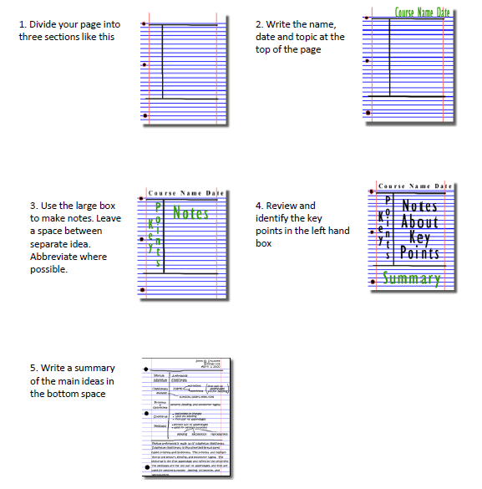

**Research Activities**

To get the best grades in A Level Chemistry you will have to get good at completing independent research and making your own notes on difficult topics.

For each of the following topics, carry out your own research to produce one page of Cornell style notes.

**Topic 1: The chemistry of fireworks**

What are the component parts of fireworks? What chemical compounds cause fireworks to explode? What chemical compounds are responsible for the colour of fireworks?

**Topic 2: Why is copper sulfate blue?**

Copper compounds like many of the transition metal compounds have got vivid and distinctive colours – but why?

**Topic 3: Aspirin**

What was the history of the discovery of aspirin, how do we manufacture aspirin in a modern chemical process?

**Topic 4: The hole in the ozone layer**

Why did we get a hole in the ozone layer? What chemicals were responsible for it? Why were we producing so many of these chemicals? What is the chemistry behind the ozone destruction?

**Topic 5: ITO and the future of touch screen devices**

ITO – indium tin oxide is the main component of touch screen in phones and tablets. The element indium is a rare element and we are rapidly running out of it. Chemists are desperately trying to find a more readily available replacement for it. What advances have chemists made in finding a replacement for it?

**Getting ready to study…..**

A level Chemistry will use your knowledge from GCSE and build on this to help you understand new and more demanding ideas. Complete the following tasks to make sure your knowledge is up to date and you are ready to start studying.

**Chemistry topic 1 – Electronic structure, how electrons are arranged around the nucleus**

A periodic table can give you the proton / atomic number of an element; this also tells you how many electrons are in the ***atom***.

**You will have used the rule of electrons shell filling, where:**

The first shell holds up to 2 electrons, the second up to 8, the third up to 8 and the fourth up to 18 (or you may have been told 8).

At **A level** you will learn that the electron structure is more complex than this, and can be used to explain a lot of the chemical properties of elements.

The ‘shells’ can be broken down into ‘orbitals’, which are given letters:’s’ orbitals, ‘p’ orbitals and ‘d’ orbitals.

You can read about orbitals here:

<https://www.chemguide.co.uk/atoms/properties/atomorbs.html>



Now that you are familiar with s, p and d orbitals try these problems; write your answer in the format: 1s², 2s², 2p⁶ etc.

1. Write out the electron configuration of:

a) Ca b) Al c) S d) Cl e) Ar f) Fe g) V h) Ni i) Cu j) Zn k) As

2. Extension question, can you write out the electron arrangement of the following ***ions***:

a) K⁺ b) O²⁻ c) Zn²⁺ d) V⁵⁺ e) Co²⁺

**Chemistry topic 2 – Oxidation and reduction**

At GCSE you know that oxidation is adding oxygen to an atom or molecule and that reduction is removing oxygen, or that oxidation is removing hydrogen and reduction is adding hydrogen. You may have also learned that oxidation is removing electrons and reduction is adding electrons.

At A level we use the idea of ***oxidation number*** a lot!

You know that the metals in group 1 react to form ions that are +1, i.e. Na⁺ and that group 7, the halogens, form -1 ions, i.e. Br⁻

We say that sodium, when it has reacted has an oxidation number of +1 and that bromide has an oxidation number of -1.

All atoms that are involved in a reaction can be given an oxidation number.

An element, Na or O2 is always given an oxidation state of zero (0), any element that has reacted has an oxidation state of + or -.

As removing electrons is **reduction**, if, in a reaction the element becomes **more** negative it has been reduced, if it becomes more positive it has been oxidised.

You can read about the rules for assigning oxidation numbers here:

<http://www.dummies.com/how-to/content/rules-for-assigning-oxidation-numbers-to-elements.html>



Elements that you expect to have a specific oxidation state actually have different states, so for example you would expect chlorine to be -1, it can have many oxidation states: NaClO, in this compound it has an oxidation state of +1

There are a few simple rules to remember:

Metals have a + oxidation state when they react.

Oxygen is ‘king’ it always has an oxidation state of -2

Hydrogen has an oxidation state of +1 (except metal hydrides)

The charges in a molecule must cancel.

Examples: Sodium nitrate, NaNO3 sulfate ion, SO4²⁻

Na +1 3x O²⁻ 4 x O²⁻ and 2- charges ‘showing’

+1 -6 -8 -2

To cancel: N = +5 S = +6

2.1 Work out the oxidation state of the **underlined** atom in the following:

a) MgCO₃ b) SO₃ c) NaClO₃ d) MnO₂ e) Fe₂O₃ f) V₂O₅ g) KMnO₄ h) Cr₂O₇²⁻ i) Cl₂O₄

**Chemistry topic 3 – The shapes of molecules and bonding.**

Have you ever wondered why your teacher drew a water molecule like this?

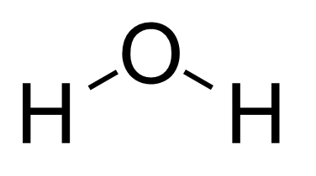

The lines represent a covalent bond, but why draw them at an unusual angle?

If you are unsure about covalent bonding, read about it here:

<https://www.chemguide.co.uk/atoms/bonding/covalent.html>



At A level you are also expected to know how molecules have certain shapes and why they are the shape they are. You can read about shapes of molecules here:

<https://www.chemguide.co.uk/atoms/bonding/shapes.html#top>



3.1 Draw a dot and cross diagram to show the bonding in a molecule of aluminium chloride (AlCl₃)

3.2 Draw a dot and cross diagram to show the bonding in a molecule of ammonia (NH₃)

3.3 What is the shape and the bond angles in a molecule of methane (CH₄)?

**Chemistry topic 4 – Chemical equations**

Balancing chemical equations is the stepping-stone to using equations to calculate masses in chemistry.

There are loads of websites that give ways of balancing equations and lots of exercises in balancing.

Some of the equations to balance may involve strange chemical, don’t worry about that, the key idea is to get balancing right.

<http://www.chemteam.info/Equations/Balance-Equation.html>

<https://phet.colorado.edu/en/simulation/balancing-chemical-equations>

4.1 Balance the following equations:

a. H₂ + 0₂ H₂0

b. S₈+ 0₂ S0₃

c. HgO  Hg+ 0₂

d. Zn+ HCl ZnCl₂ + H₂

e. Na+ H₂0  NaOH + H₂

f. C₁₀H₁₆ + Cl₂ C + HCl

g. Fe+ 0₂ Fe₂0₃

h. C₆H₁₂0₆ + 0₂  C0₂ + H₂0

i. Fe₂0₃ + H₂  Fe + H₂0

j. Al + FeO  Al₂O₃ + Fe

**Chemistry topic 5 – Measuring chemicals – the mole**

From this point on you need to be using an A level periodic table -you can view one here:



Now that we have our chemical equations balanced, we need to be able to use them in order to work out masses of chemicals we need or we can produce.

The ***mole*** is the chemists equivalent of a dozen, atoms are so small that we cannot count them out individually, we weigh out chemicals.

For example: magnesium + sulfur magnesium sulfide

Mg + S  MgS

We can see that one atom of magnesium will react with one atom of sulfur, if we had to weigh out the atoms we need to know how heavy each atom is.

From the periodic table: Mg = 24.3 and S = 32.1

If I weigh out exactly 24.3g of magnesium this will be 1 mole of magnesium, if we counted how many atoms were present in this mass it would be a huge number (6.02 x 1023!!!!), if I weigh out 32.1g of sulfur then I would have 1 mole of sulfur atoms.

So 24.3g of Mg will react precisely with 32.1g of sulfur, and will make 56.4g of magnesium sulfide.

Here is a comprehensive page on measuring moles, there are a number of descriptions, videos and practice problems.

You will find the first 6 tutorials of most use here, and problem sets 1 to 3.

<http://www.chemteam.info/Mole/Mole.html>

5.1 Answer the following questions on moles.

a) How many moles of phosphorus pentoxide (P₄O₁₀) are in 85.2g?

b) How many moles of potassium in 73.56g of potassium chlorate (V) (KClO₃)?

c) How many moles of water are in 249.6g of hydrated copper sulfate(VI) (CuSO₄.5H₂O)? For this one, you need to be aware the dot followed by 5H2O means that the molecule comes with 5 water molecules so these have to be counted in as part of the molecules mass.

d) What is the mass of 0.125 moles of tin sulfate (SnSO₄)?

e) If I have 2.4g of magnesium, how many g of oxygen (O₂) will I need to react completely with the magnesium? 2Mg +O₂ MgO

**Social Media**

Suggestions of people to follow on Twitter:

* Chemistry magazine bringing you the latest chemistry news and research every day. Published by the Royal Society of Chemistry.

@ChemistryWorld

* Here to give every mind in the chemical sciences the support, resources and connections they need to shape chemistry’s future.

@RoySocChem

* This is the twitter account for anyone studying chemistry A Level.

@ChemistryALevel

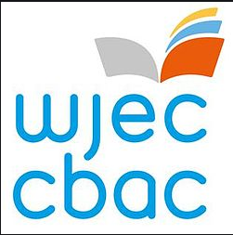**Keeping it Fresh……..**

It is important to keep the knowledge you have gained at GCSE fresh in your mind ready to start your A levels in September.

Why not spend some time looking over some past papers and using the mark schemes to assess how well you’ve done.

Chemistry GCSE Units 1 and 2 – Past Papers and Marking Schemes:

<https://www.wjec.co.uk/qualifications/qualification-resources.html?subject=Chemistry&level=gcsefrom2016&pastpaper=true>

Science Double Award GCSE Units 2 and 5 – Past Papers and marking Schemes:

<https://www.wjec.co.uk/qualifications/qualification-resources.html?subject=sciencedoubleAward&level=gcsefrom2016&pastpaper=true>

**Planning Ahead…….**

In order to prepare yourself for further study, have a look at the resources below:

|  |  |
| --- | --- |
| WJEC Specification – GCE AS/A Level in Chemistry | https://www.wjec.co.uk/qualifications/science/as-a-level/chemistry-as-a-level-2015/wjec-gce-chemistry-spec-from-2015.pdf |
| WJEC Specimen Assessment Materials | https://www.wjec.co.uk/qualifications/science/as-a-level/chemistry-as-a-level-2015/wjec-gce-chemistry-sams-from-2015.pdf |
| WJEC Past Papers and Marking Schemes | https://www.wjec.co.uk/qualifications/qualification-resources.html?subject=Chemistry&level=gceAsafrom2015&pastpaper=true |
| WJEC AS/A Level Chemistry Lab Book | https://www.wjec.co.uk/qualifications/science/as-a-level/chemistry-as-a-level-2015/Chemistry%20lab%20book%20English.pdf |
| Revision Guide – Units 1 and 2 | https://resources.wjec.co.uk/Pages/ResourceSingle.aspx?rIid=2959 |
| Revision Guide – Unit 3 | https://resources.wjec.co.uk/Pages/ResourceSingle.aspx?rIid=2735 |
| Revision Guide – Unit 4 | https://resources.wjec.co.uk/Pages/ResourceSingle.aspx?rIid=2768 |